Data modeling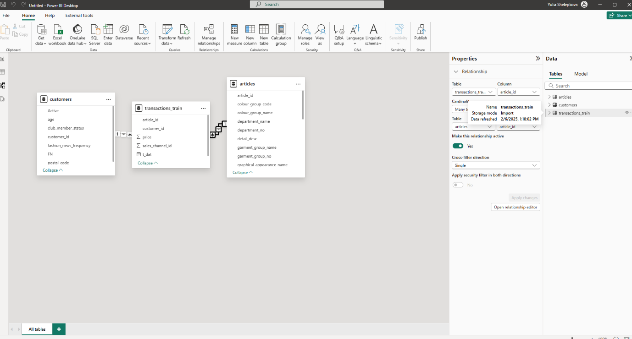

Creating layout

Validating data, checking blanks, nulls and errors
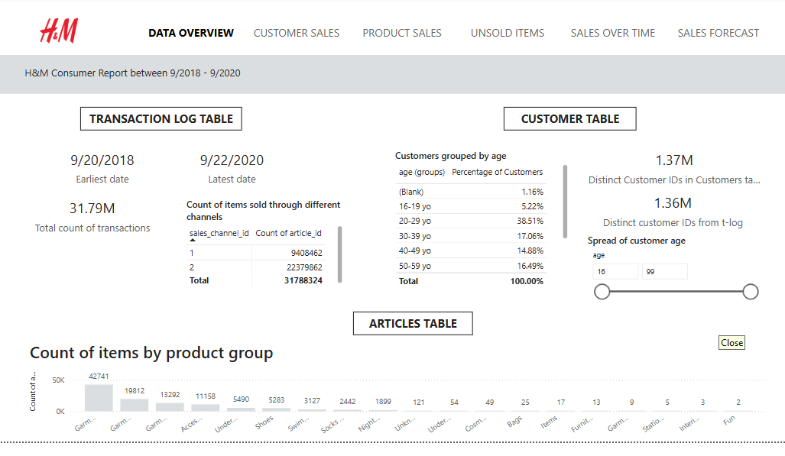

Grouping customers by age and creating measure to calculate percentages
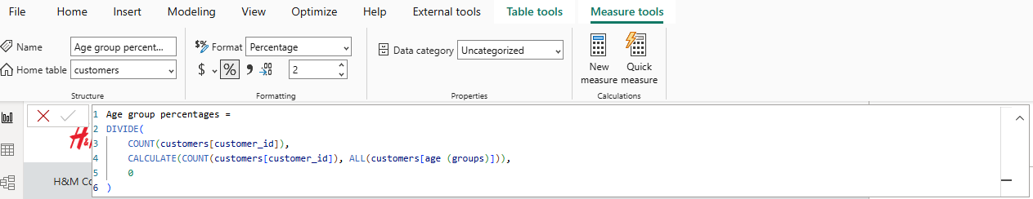

Customer sales
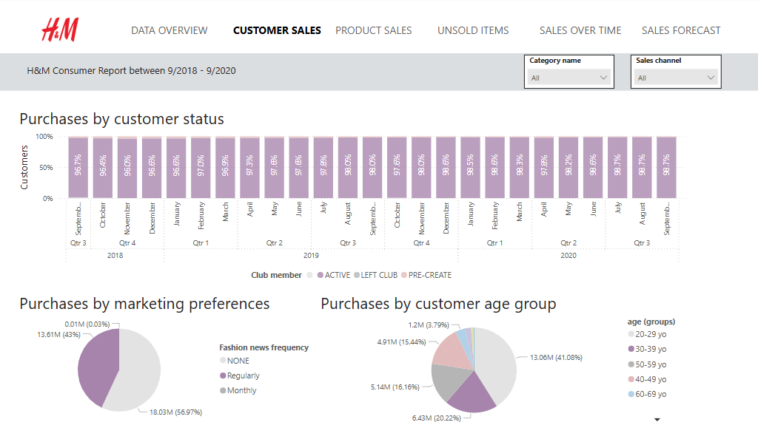

Product sales
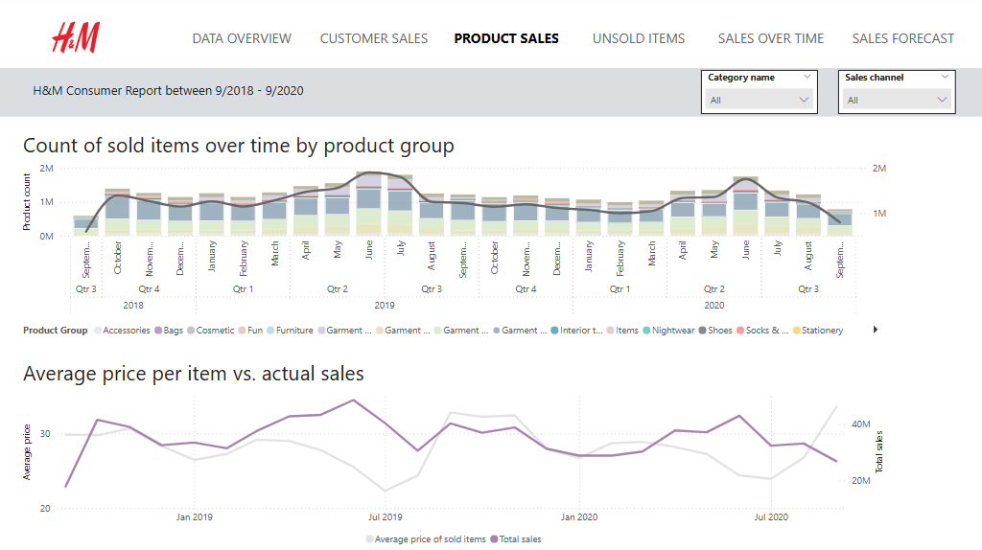

Unsold items
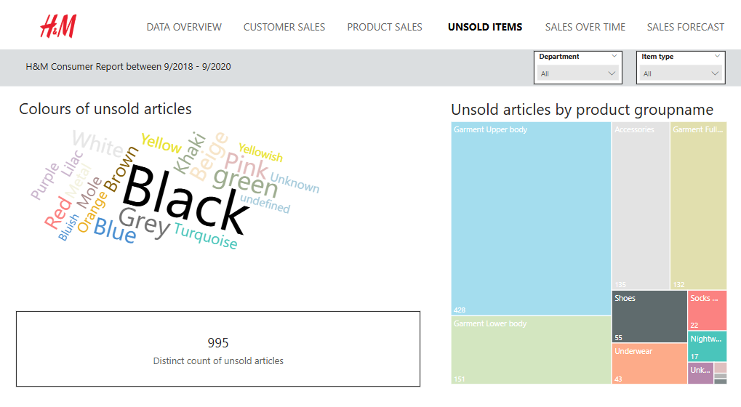
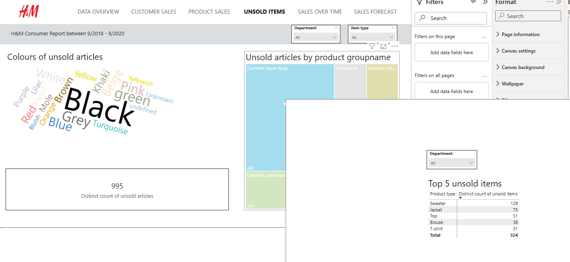

Sales over time
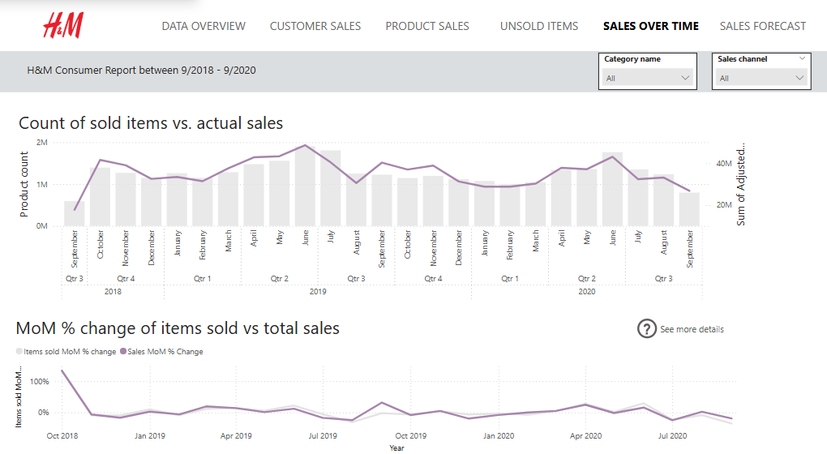

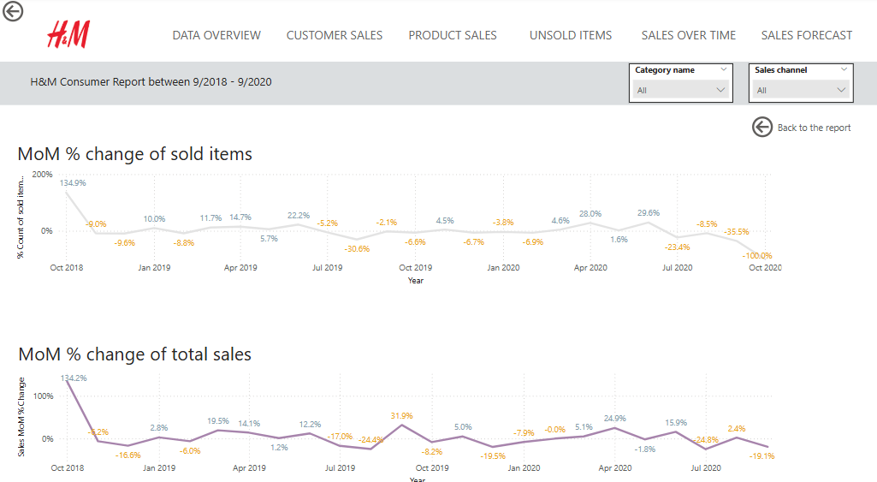

We see that during in September 2019 2,2% less items were sold but the total sales increased by 31%. Which would be interesting to research further. Consequently in June 2020 almost 30% more items were sold by total sales went up only by 16% compared to previous month

Sales forecast
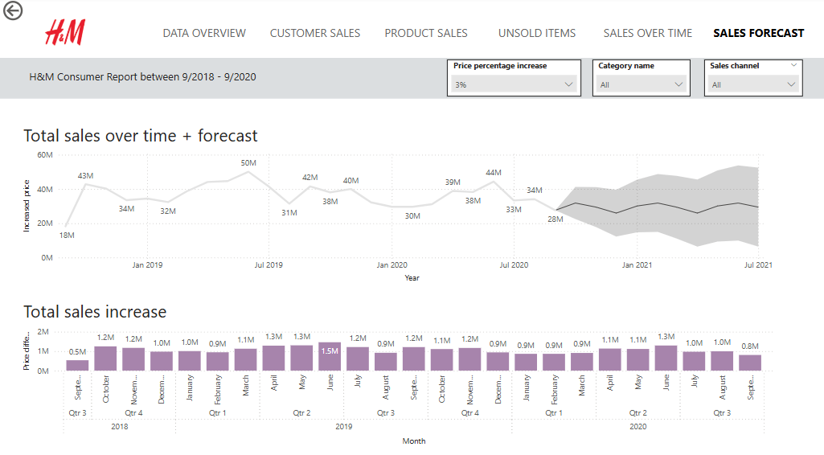
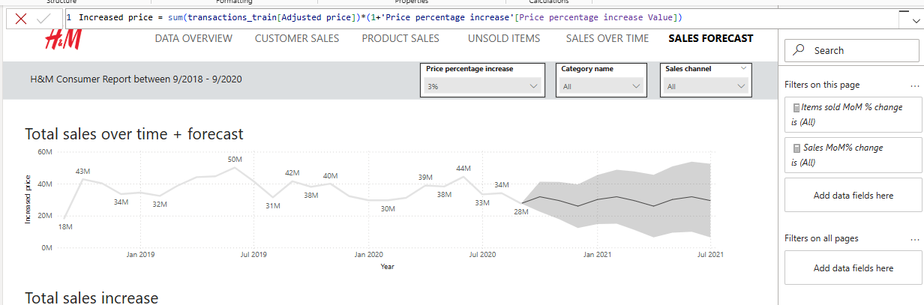
Looking and seasonal picks
Calculating MoM % Change
Customer profile
Purchases by marketing preferences - push for selecting newsletters or in app alerts
Purchases by customer group – share of different age groups changes depending on sales channel

Sales over time

Product sales
Average price vs total sales
Count of unique unsold items
Tooltip with top five unsold products

